Prompting Techniques for Instruction-Following Document Generation Using LLMs

1. Experimental Plan Overview
The objective of this study is to systematically evaluate the effectiveness of various prompting techniques on large language models (LLMs) in instruction-following tasks. These tasks are grounded in a model validation use case, where the LLM is asked to produce professional-quality assessments based on instructions and excerpts from model development documents (MDDs).
The experiment evaluates how prompting strategies affect the quality of responses in terms of relevancy, completeness, and specificity. The ultimate goal is to inform prompt engineering practices for model risk management documentation tasks.

2. Prompting Techniques Evaluated
The following prompting techniques were included:
- Zero-shot
- Few-shot
- Zero-shot Chain-of-Thought (CoT)
- Few-shot Chain-of-Thought (Few-shot CoT)
- Tree of Thought
- ReAct (Reasoning + Action + Self-Criticism)
Each technique was implemented using carefully designed prompt templates based on established best practices from prior literature.

3. Data Used
The dataset includes 10 instruction-context pairs:
- Instructions are based on publicly available model validation templates (e.g., "Assess whether assumptions are clearly stated and validated"). Developed based on SR 11-7 and Sudjianto 2024
- Context is drawn from a synthetic Model Development Document (MDD) describing an NLP model for Elder Financial Abuse (EFA) classification.
All data was human-curated and free of sensitive information.

4. Models Used
The experiments reported here have been run using the gpt-4o model (OpenAI). The experiments using additional open-source models LLaMA 3 and Qwen 7B are in progress.

5. Evaluation Metrics
Each response is evaluated on:
- Relevancy (1–5): Does the response directly address the instruction?
- Completeness (1–5): Are all required elements addressed?
- Specificity (1–5): Are the statements grounded in the context?
Error types are also logged:
- Hallucination
- Redundancy
- Lack of specificity

6. Results So Far
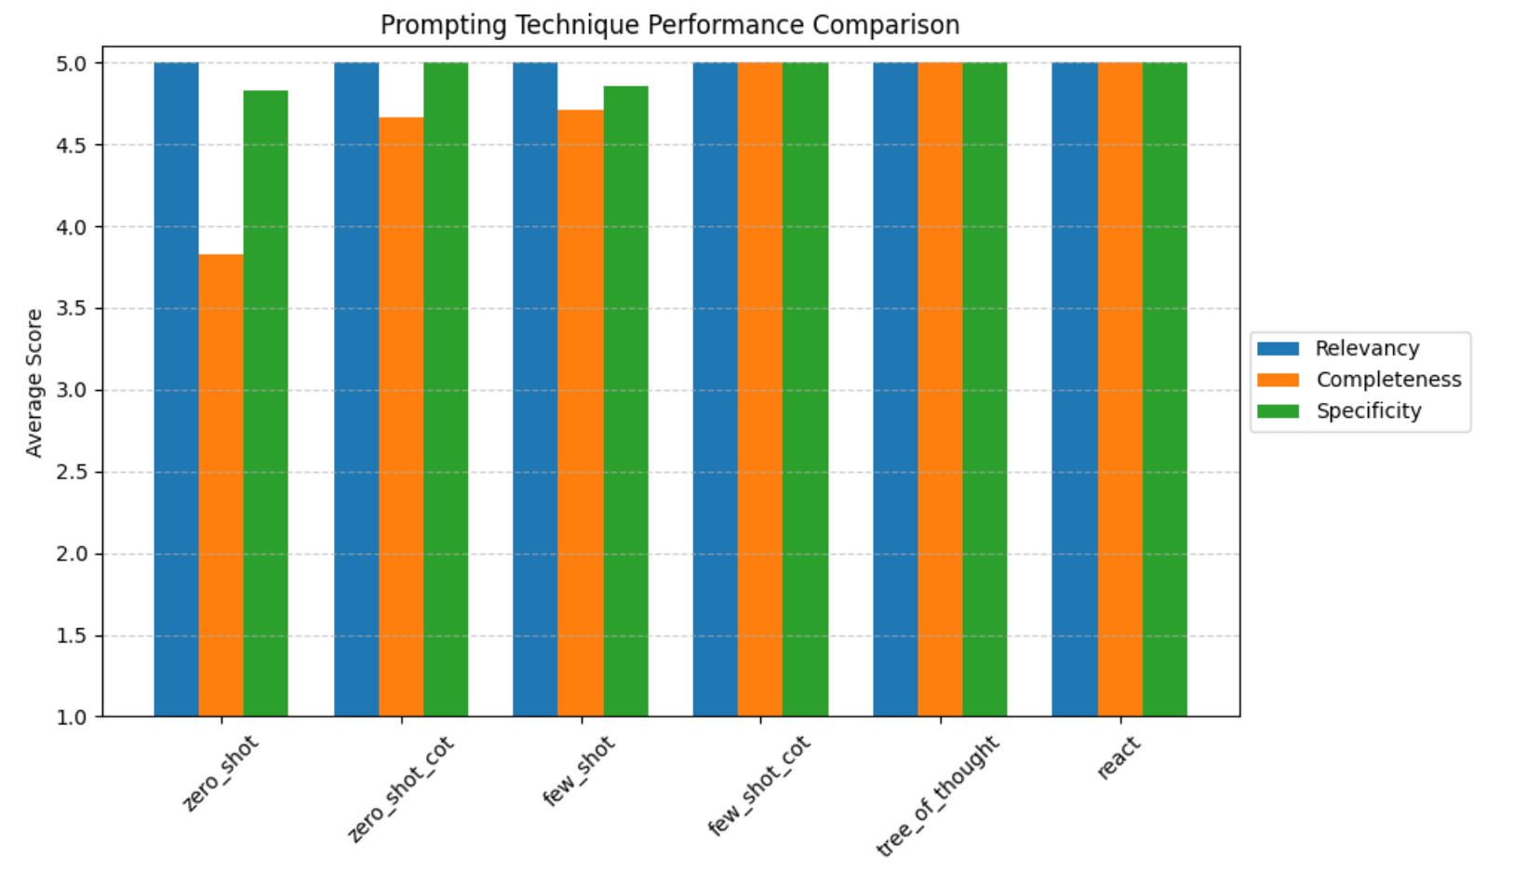
Technique | Relevancy | Completeness | Specificity
Zero-shot | 5.00 | 3.83 | 4.83
Zero-shot CoT | 5.00 | 4.67 | 5.00
Few-shot | 5.00 | 4.71 | 4.86
Few-shot CoT | 5.00 | 5.00 | 5.00
Tree of Thought | 5.00 | 5.00 | 5.00
ReAct | 5.00 | 5.00 | 5.00
Discussion:
- Few-shot CoT, Tree of Thought, and ReAct techniques produced the highest quality outputs across all metrics.
- Zero-shot prompting produced relevant but less complete responses.
- Few-shot prompting helped boost completeness without sacrificing specificity.
- The Chain-of-Thought techniques improved the structure and reasoning quality of responses.

7. Limitations
- Only one model (gpt-4o) has been evaluated.
- Dataset size is relatively small (10 examples). (Each example was repeated 3 times)
- The domain is narrow (model validation for risk/compliance) and may not generalize.

8. Comparison with Prior Work
Compared to the findings in the Prompt Report survey (arXiv:2307.05230), our results are aligned in several key ways:
- Few-shot and CoT prompting consistently outperform zero-shot prompting.
- Structured prompts like ReAct and ToT add reasoning and self-correction, which improves overall quality.
- Like the survey, we observe diminishing returns in performance gains when moving from CoT to even more complex prompting.
Our study is unique in focusing on document validation tasks within a regulatory setting—an area underrepresented in prior benchmarking studies.

9. Remaining Tasks
- Run the same experiments using open-source models (e.g., LLaMA 3, Qwen 7B).
- Expand the dataset with more instructions and diverse context types.
- Evaluate cost-effectiveness and latency of different techniques.
- Automate metric scoring and error classification.

